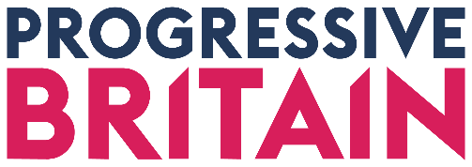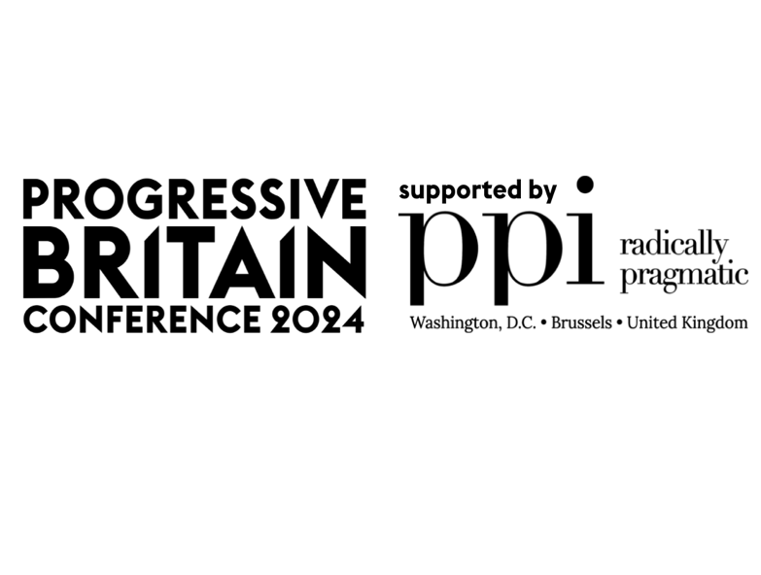

Building Britain’s Future
Progressive Britain annual conference
11 May 2024, etc venues, 133 Houndsditch, London
Programme timings and speakers subject to change – speakers listed below are confirmed (as at 9 May)

8.30 | Registration and networking |  |  |  | Labour to win campaign stream
9.30-9.45 | Welcome and conference opening
9.45-10.30 | Keynote: A year of two elections  Guest speaker  In conversation with Will Marshall, President and Founder, PPI  Chair: Ayesha Hazarika  Venue: Enterprise Suite
10.30-11.00 | Refreshment and networking break
11.00.11.45 | Mission breakout 1  Growth – Integrate 1  Growth for everyone  Justin Madders, Shadow Minister for Business, Employment Rights and Levelling Up  Dan Tomlinson, PPC Chipping Barnet  Daniel Johnson MSP, Spokesperson on the Economy, Business and Fair Work  Shreya Nanda, Senior Fellow, Social Market Foundation  Cathleen Clarke, LabourList (Chair) | Mission breakout 2  Net Zero and Energy - Interact  The clean dream: Labour's strategy for Green power  Alan Whitehead, Shadow Minister for Energy Security  Daisy Powell-Chandler, Partner and Head of Energy and Environment Practice at Public First  Andy Prendergast, National Secretary, GMB  Paul McNamee, Director, Labour Climate and Environment Forum  Russell Hargreave, Editor of Politico Energy (Chair) | Mission breakout 3  Track sponsored by Forensic Analytics  Crime – Synergy 2  Preventing polarisation: Tackling hate crime, extremism, and conspiracy  Feryal Clark MP, Shadow minister for crime reduction  Sara Hyde, Chair, Fabian Society  Panellist to be confirmed  Ayesha Hazarika (Chair) | Mission breakout 4  Opportunity – Integrate 2  Is Labour serious about class?  Anneliese Dodds, Shadow Secretary of State for Women and Equalities  Sarah Atkinson, Chief Executive, Social Mobility Foundation  Nick Bent, Chief Executive, upReach  Lisa Banes, PPC for Thirsk & Malton  Rachel Wearmouth, I paper (Chair) | Organising the Grassroots 2.0 - Hannah O'Rourke, Campaign LAB  Venue: Engage  Join us for an interactive workshop designed to transform your approach to grassroots organising using cutting-edge technology. In just one hour, you'll learn how to:  - Mobilize Like a Pro: Discover strategies to activate your supporters and build energy from the ground up.  - Tell a Compelling Political Story: Learn the art of crafting narratives that resonate with online audiences, helping your message stand out amid digital noise.  - Leverage AI for Campaign Success: Explore how artificial intelligence can enhance your campaign's efficiency.
12.00-12.45 | Plenary  Alison McGovern MP, Shadow Minister (Work and Pensions)  Chair: Rachel Wearmouth  Venue: Enterprise Suite

12.45-13.30 | Networking break – lunch options off-site
13.30-14.15 | Mission breakout 5  Track sponsored by Forensic Analytics  Crime – Synergy 2  Safe everywhere, or safety no-where: How do Labour tackle a culture of violence against women and girls wherever it appears?  Alex Davies Jones MP, Shadow Minister for Domestic Violence and Safeguarding  Andrea Simon, Director of End Violence Against Women Coalition  Tom Hayes, PPC Bournemouth  Andrew Fahey, Business Development Director, Forensic Analytics  Lara Spirit, Red Box Editor, The Times (Chair) | Mission breakout 6  Growth – Integrate 1  How to deliver the housing we need while protecting the countryside  Session sponsored by CPRE, The Countryside Charity  Roger Mortlock, Chief Executive, CPRE, The Countryside Charity  Shama Tatler, Cabinet Member for Regeneration, Planning and Growth, London Borough of Brent  Hywel Lloyd, Co-founder, Labour Coast and Country  Kane Emerson, Head of Housing Research, Yimby Alliance  Danny Beales, PPC Uxbridge and Ruislip  Anna Clarke, Director of Policy and Public Affairs, Housing Forum (Chair) | Mission breakout 7  Health – Synergy 1  Mental Health in Crisis: Can Labour get treatment to those who want it  Jake Mills, Comedian and founder, Chasing the Stigma  Luciana Berger, Review lead, Labour's mental health review  Dr Sarah Hughes, Chief Executive, MIND  Noa Hoffman, Journalist, The Sun (chair) | Mission breakout 8  Opportunity – Integrate 2  Ending Hardship Through Good Work  Andrew Pakes, deputy General Secretary, Prospect  Rachel Sandby-Thomas, Skill's advisor for Labour's 2022 skills report & ex-Director General of Skills at Dept of Business & Skills 2010-2016  Claire Ainsley, Director of the Project on Center-Left Renewal, PPI  Kitty Ussher, Economist and former politician  Abdi Duale, Labour NEC Member and Senior Director, Public Affairs, FTI Consulting (Chair) | Cutting through with compelling content  Venue: Engage  Campaigns should tell stories that inspire people to champion change. Join the team from We Are Civitas who will walk you through design and digital best practice. This will include mapping15.30 what tools are out there to help your campaigns; compelling messaging and content; understanding all things digital to help turn your campaign into a winning campaign
14.25-15.10 | Mission breakout 9  Net Zero and Energy - Interact  Regenerating our environment, regenerating our places: Municipal green growth  Oliver Coppard, Mayor of South Yorkshire  Georgia Gould, Leader of Camden Council  Peter Mason, Leader, Ealing Council  Elan Sykes, Director of Energy and Climate Policy, PPI  Nathan Yeowell, Director, Future Governance Forum (Chair/speaker) | Mission breakout 10  Growth – Integrate 1  Do we need a Cultural Industrial Strategy?  Chris Bryant MP, Shadow Minister for Creative Industries and Digital  Professor Dave O’Brien, Professor of Cultural and Creative Industries at The School of Arts, Languages and Cultures at The University of Manchester  Casey Calista - Industry Chair, Labour Digital  Mitchell Simmons, Paramount, Vice President, Public Policy and Government Affairs EMEA, Paramount Global  Lisa Hayley-Jones, Director of Government and Policy Affairs, Advertising Association (Chair) | Mission breakout 11  Track sponsored by Forensic Analytics  Crime – Synergy 2  You've been scammed! Cracking down on fraudsters  Steve Rick, Chief Executive, Forensic Analytics  Tijs Broeke, incoming Chair of the Policy Authority Board, City of London Corporation  Rachel Blake, PPC CIties of London and Westminter  Helen Fairfax-Wall, Which?  Niamh McIntyre, Bureau of Investigative Journalism (Chair) | Mission breakout 12  Health – Synergy 1  Fair Care: Can Labour deliver high-quality and accessible care for all?  Dr Mary-Ann Stephenson, Director, UK Women’s Budget Group  Nathan Jones, Senior Policy and External Affairs Lead, National Care Forum  Juliet Campbell, PPC Broxtowe  David Brindle, Chair, Ambient Support and former public services editor, The Guardian (Chair) | Short campaign planning  Venue: Engage  What are the elements to execute the perfect short campaign? Join us from Labour to Win as we go through what should be in your campaign grid; digital strategy; postal votes; mobilising; eve of poll and polling day - and the count.
15.10-15.30 | Networking break  One Boy, Two Bills and a Fry Up – Wes Streeting Book Signing
15.30-16.15 | Mission breakout 13  Growth – Integrate 1  A.I - Hype or hope?  Richard Serunjogi, Venture Partner at Pioneer Fund (Y Combinator alumni) and Senior Advisor on Frontier Technology  Samantha Niblett, Labour Women in Tech and PPC South Derbyshire  Dom Hallas, Executive Director, Startup Coalition  Hannah O'Rourke, Campaign Lab (Chair) | Mission breakout 14  Health – Synergy 1  Can Labour Save the NHS?  Zubir Ahmed, PPC Glasgow  Anna Dixon, independent social care expert and PPC Shipley  David Brindle, Chair, Ambient Support and former public services editor, The Guardian (Chair) | Mission breakout 15  Net Zero and Energy - Interact  Filth or flourishing? How can Labour tackle the degradation of our rivers, seas and natural environment?  Unfortunately, we have had to cancel this session | Mission breakout 16  Opportunity – Integrate 2  Generation Opportunity? Real support for families and young children  Stella Creasy MP, Walthamstow  Ellen Broome, managing director, Coram Family and Childcare  Lucy Rigby, PPC Northampton North  Fiona Simpson, Children & Young People Now (Chair) | Campaigning ‘how to win’  Venue: Engage
16.20-17.00 | Plenary  Health – Wes Streeting MP, Shadow Secretary of State for Health and Social Care  Chair: Noa Hoffman  Venue: Enterprise Suite
17.00 | Finish – drinks locally

